CS-23334 FUNDAMENTALS OF DATA SCIENCE
ASHWIN C 240701058

Experiment 4 Date: 21.08.2025

4. Experiment to detect outliers in a given data set.

Aim:
To Understand the procedure to identify the outliers in a given dataset

Description:
Identify outliers in dataset using pandas library in python

Algorithm:

Step 1: Data Collection and Preprocessing
Step 2: Statistical Methods for Outlier Detection
Step 3: Visualization of Outliers
Step 4: Interpretation and Handling of Outliers

Code With Output:

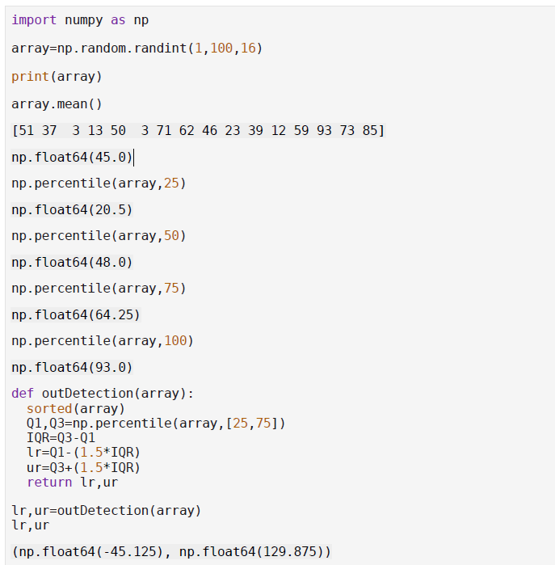

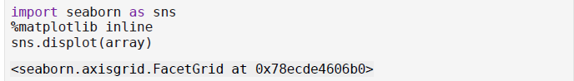

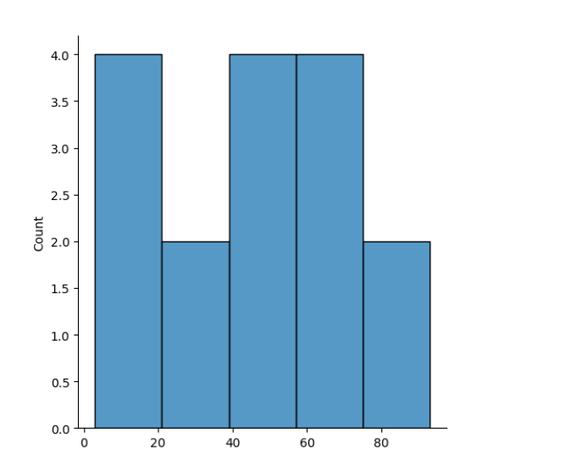

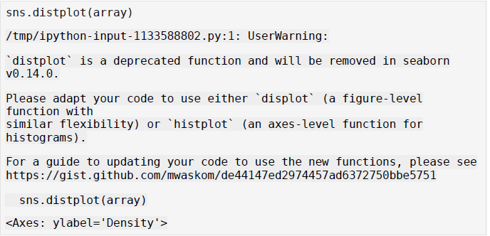

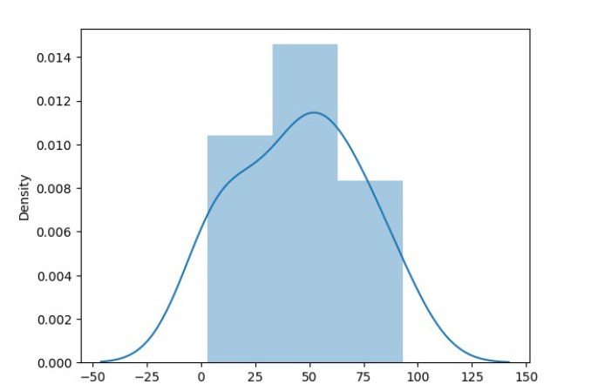

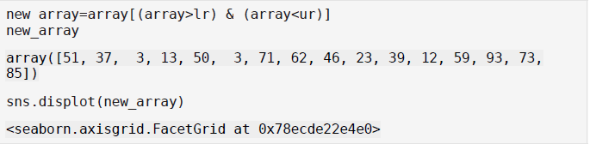
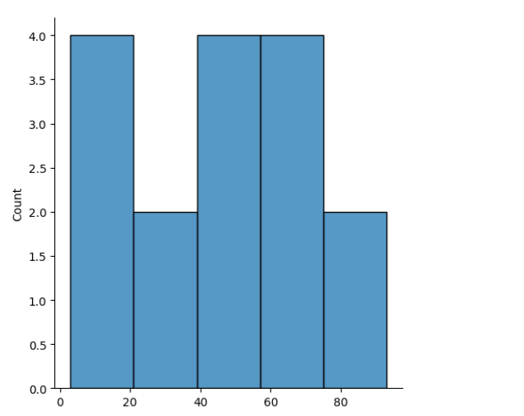

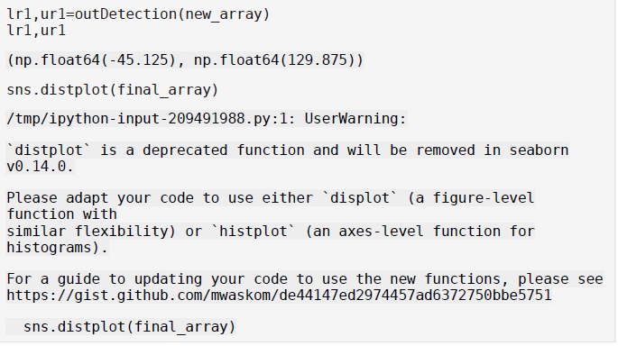

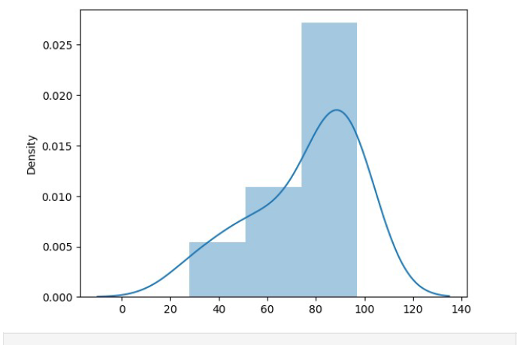

Result:
Thus the experiment to detect outliers in dataset is completed using python.

